INTEGRAL UNIVERSITY



**LAB REPORT**

**Software Engineering**

**(CS-217)**

SUBMITTED BY: SUBMITTED TO:

*FARIHA FATIMA MR. MOHAMMAD USMAN KHAN*

*B.TECH (CSE-1) (ASSISTANT PROFESSOR)*

*SECOND YEAR MR. AMIT SRIVASTAVA*

*R.NO. 1701012045 (LAB INSTRUCTOR)*

*E.NO. 1700101019*

**ACKNOWLEDGEMENT**

I would like to acknowledge and extend my heartfelt gratitude to **Mr. Mohammad Usman Khan (Assistant Professor)** and **Mr. Amit Srivastava (Lab Instructor)** under whose able guidance I have prepared the Software Engineering Lab Report. They have been a constant source of encouragement and inspiration to me.

I am also indebted to my batch mates who have been a great help in the preparation of this Lab Report.

NAME- Fariha Fatima

ENROLL No.- 1700101019

**CERTIFICATE**

This is to certify that **Fariha Fatima** of B.TECH Second year has sincerely completed her “Software Engineering Lab Report ” & submitted it on time & has helped to maintain the decorum of the LAB.

**Mr. Mohammad Usman Khan Mr. Amit Srivastava**

(Assistant Professor) (Lab Instructor)

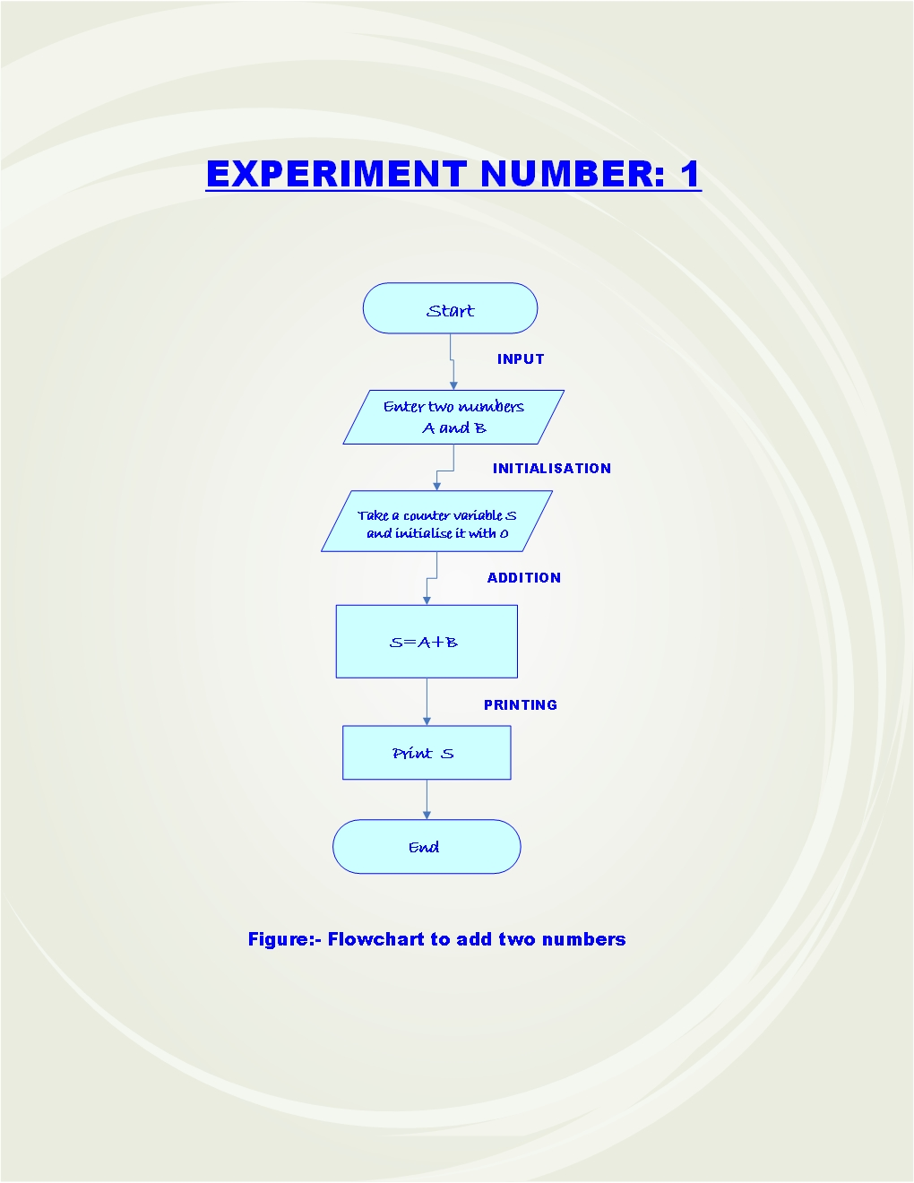

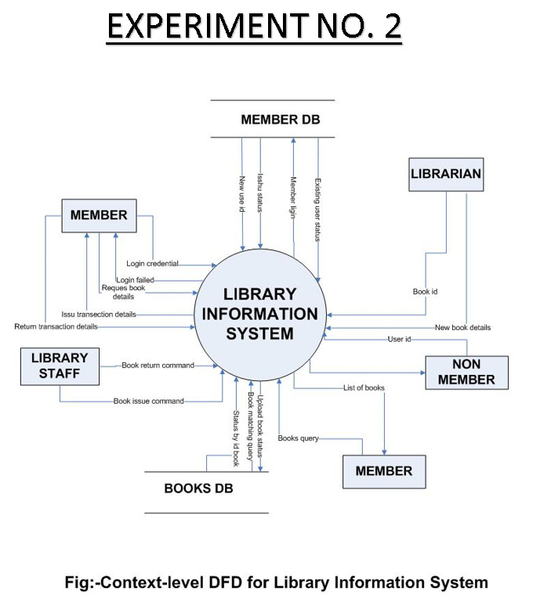

EXPERIMENT 2

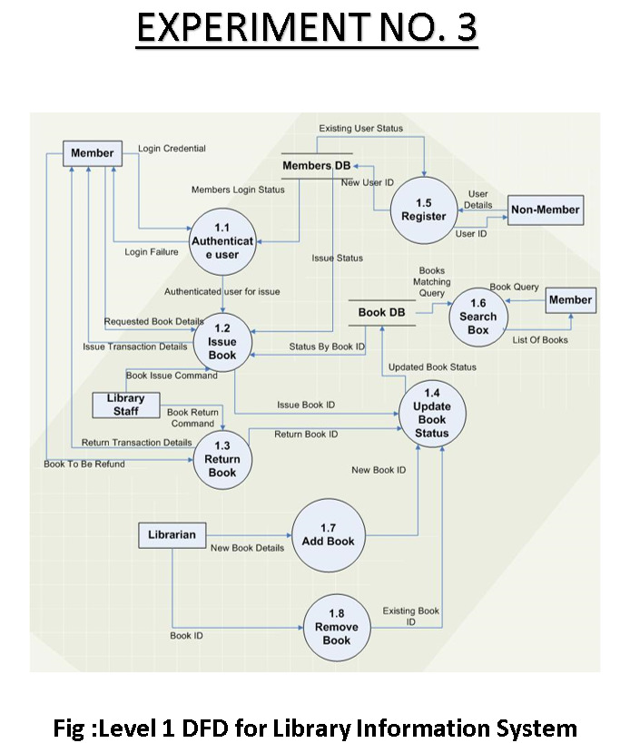

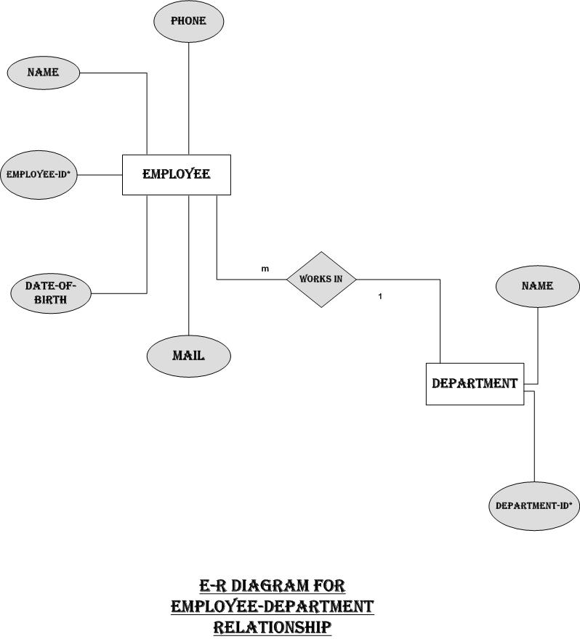

EXPERIMENT 3

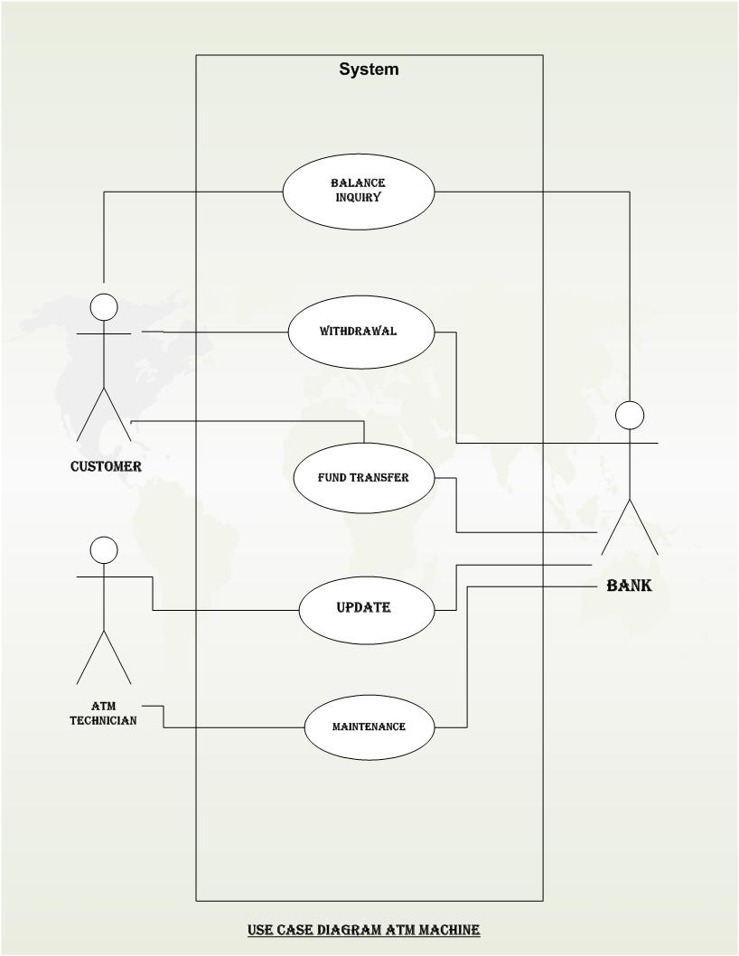

EXPERIMENT 4

**Fig: Use Case Diagram for ATM Machine**

EXPERIMENT 5

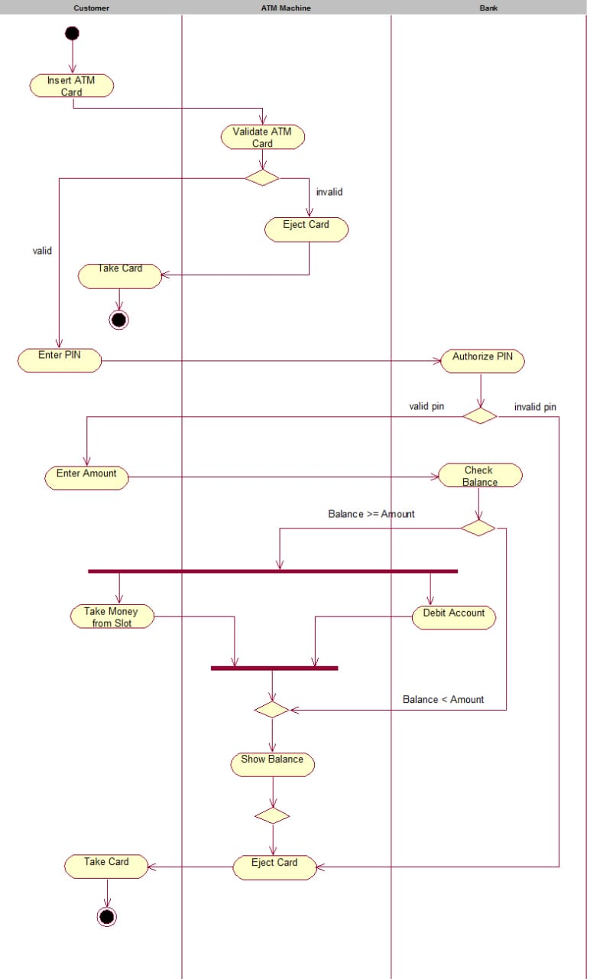

**Fig : ATM Transaction activity diagram**

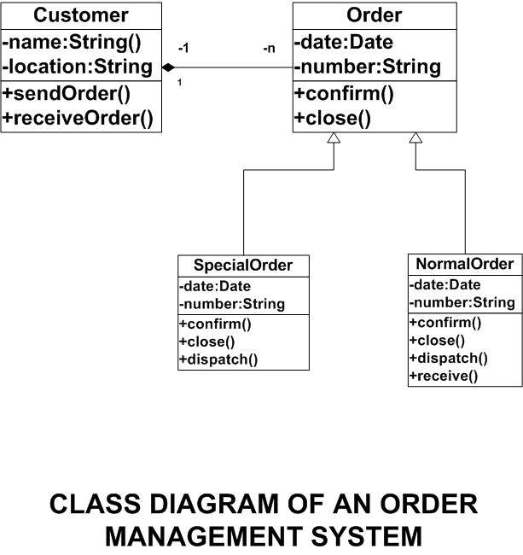

EXPERIMENT 6

EXPERIMENT 7

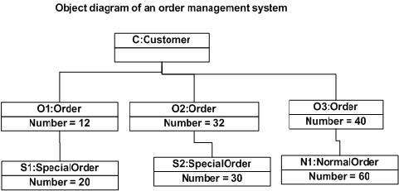

EXPERIMENT 8

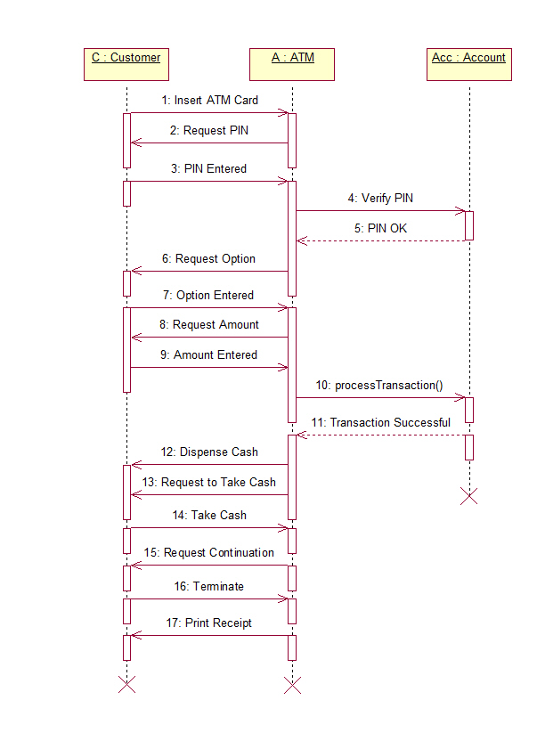

**Fig : Sequence diagram for ATM Transaction**

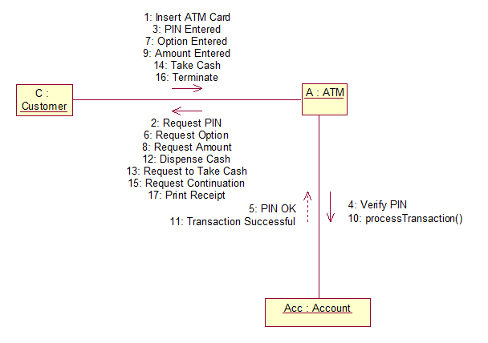

**Fig : ATM Transaction**

EXPERIMENT 9

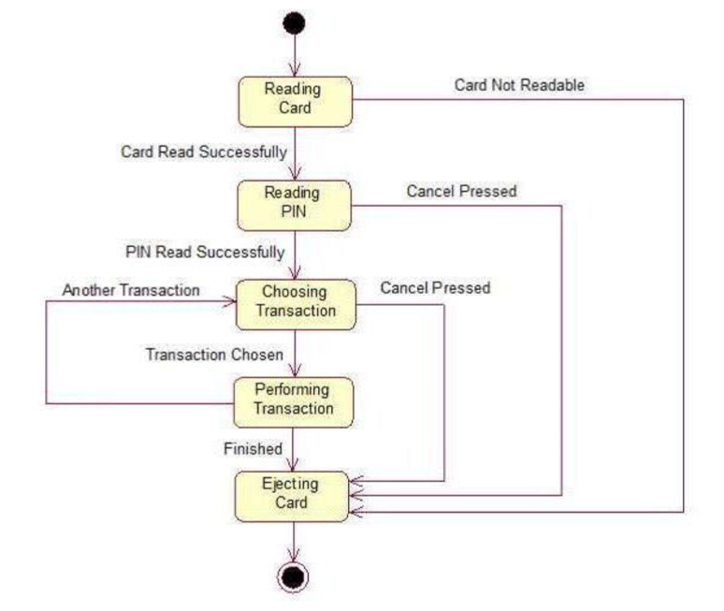

**Fig : State chart diagram for ATM transaction**